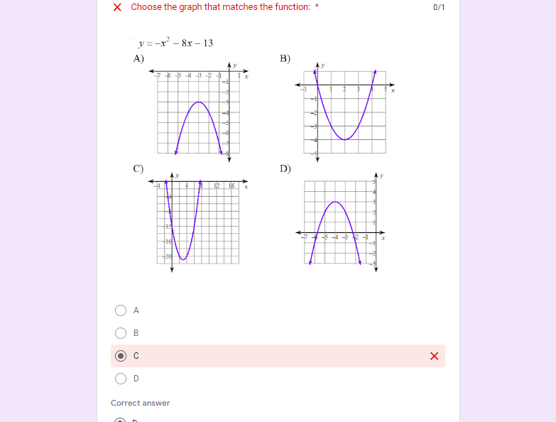

2. C

3. D

4. My answer was incorrect because I lost organization in that moment and couldn’t figure out what to do.

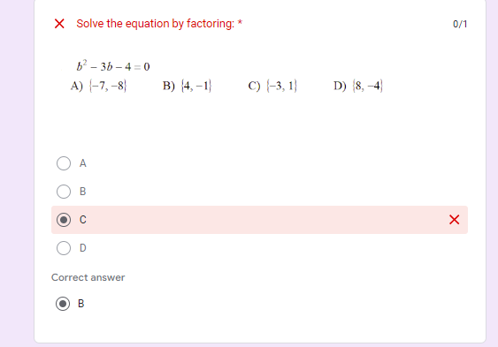

2. C

3. B

4. I messed up because my organizational skills were off and I can’t follow what I am doing.

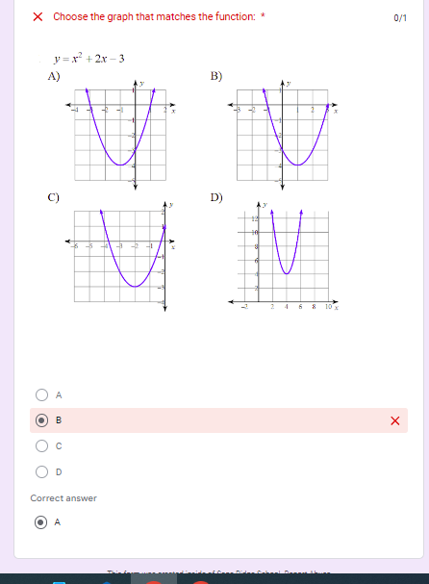

2. B

3. A

4. I got the question wrong because I messed my organizational skills up and couldn’t find my correct work.